1.open the program with idea

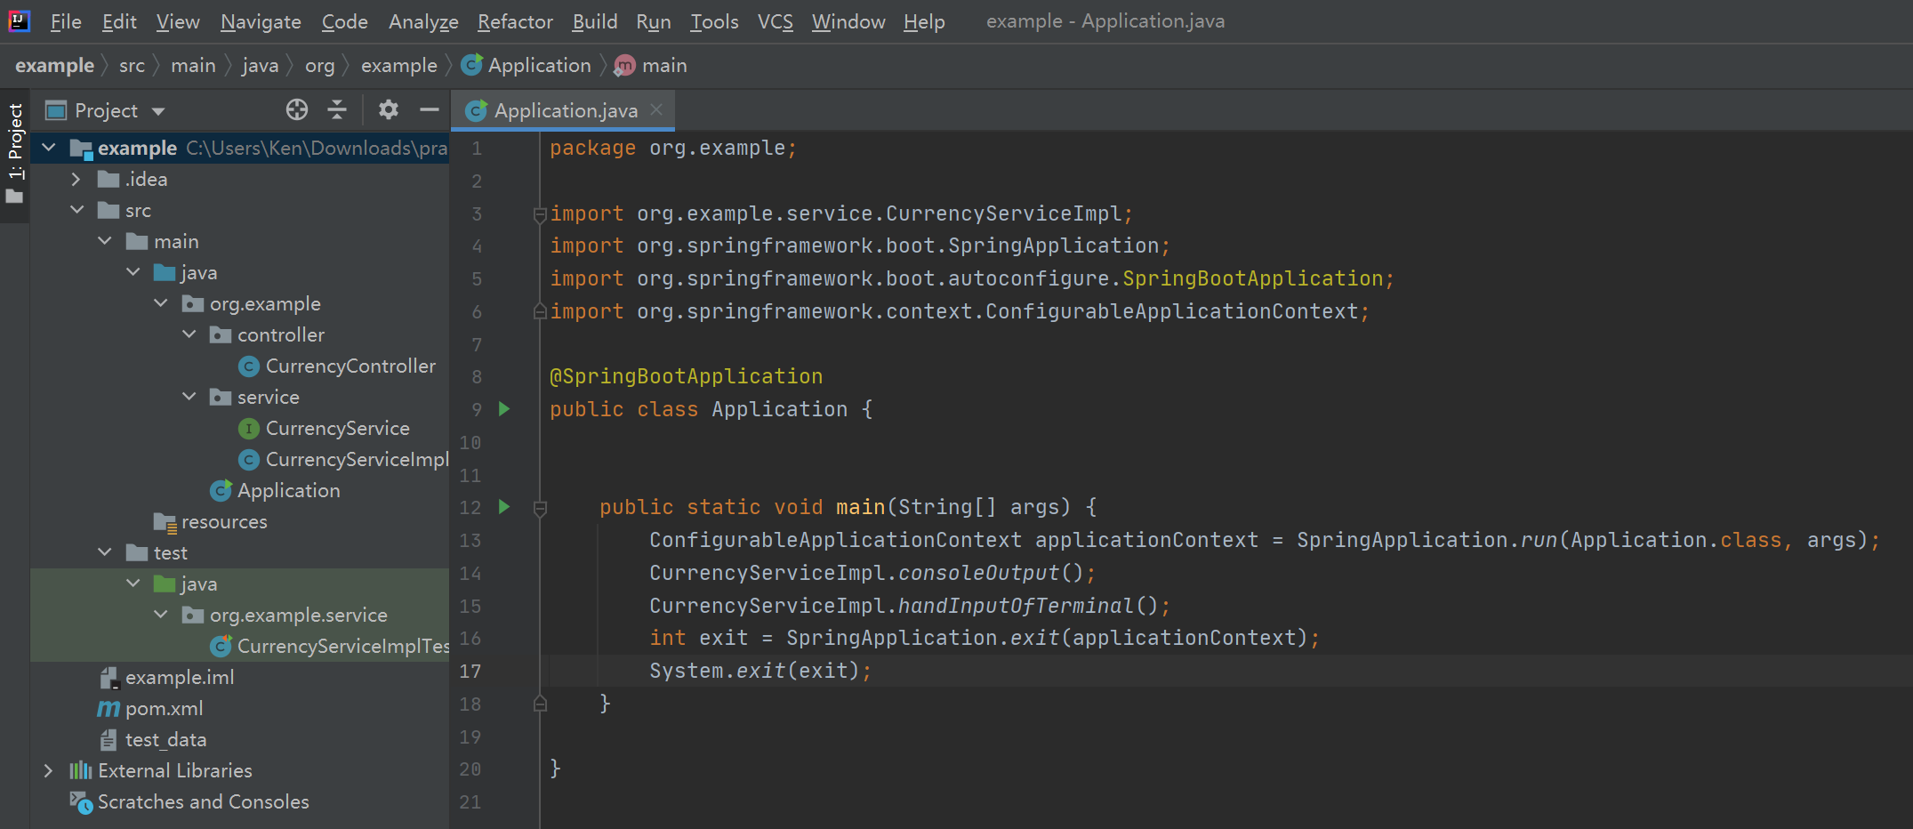

2.how to build

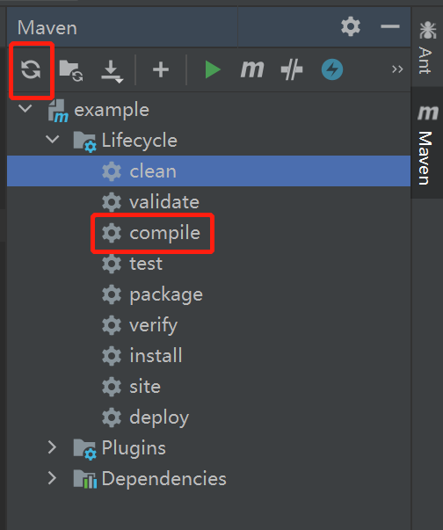

1. how run the program

Open Application file and click red line, or use Ctrl + Shift + F10

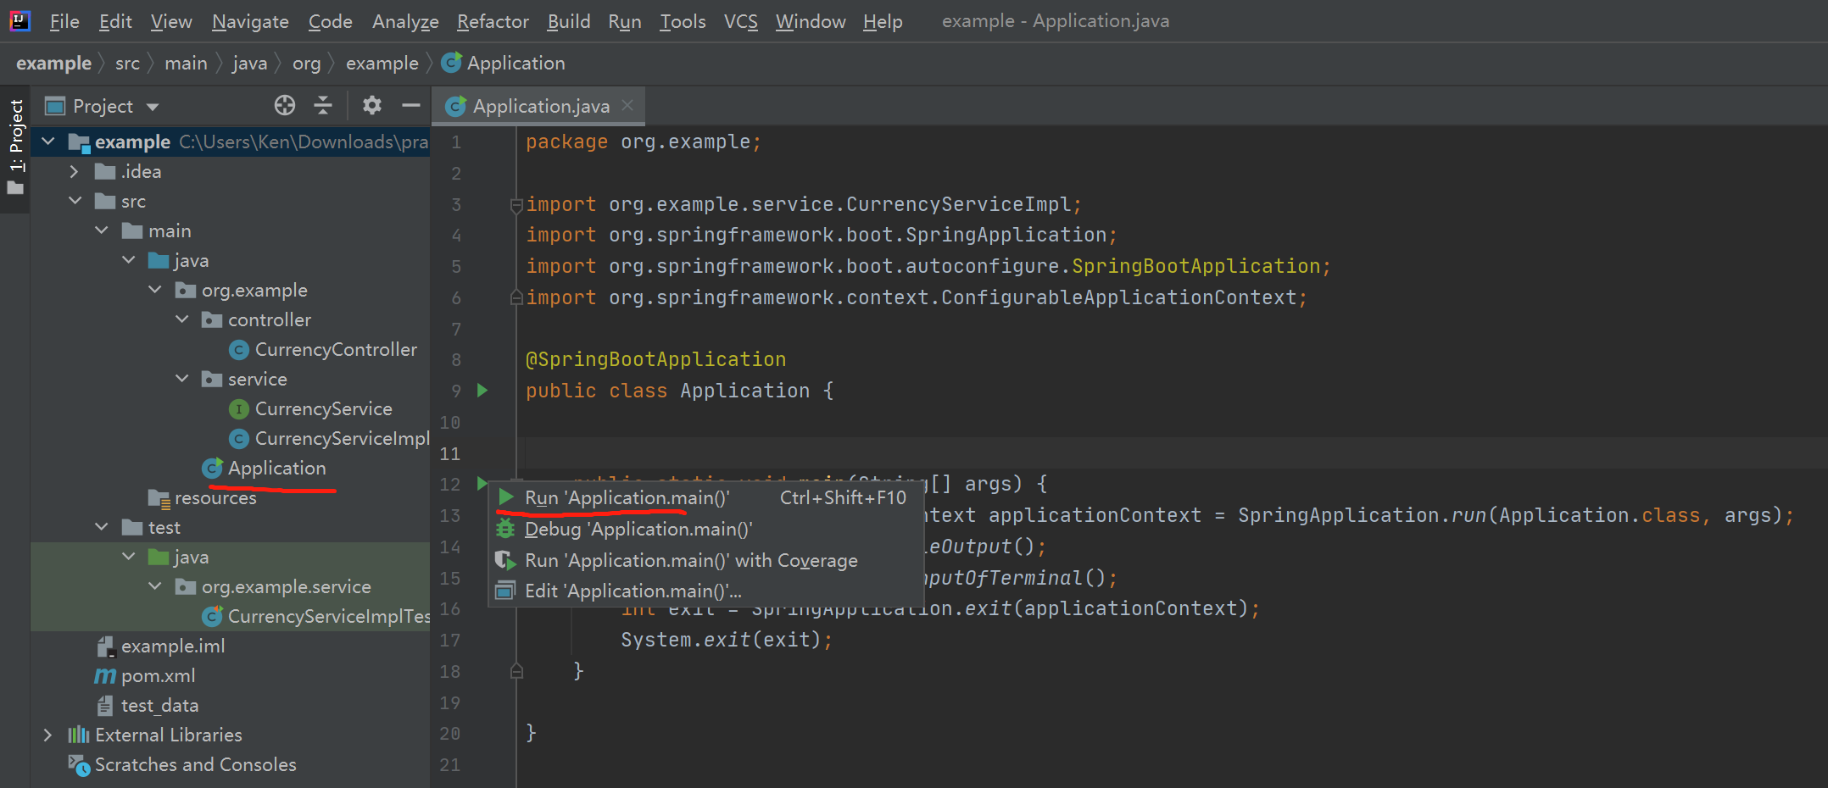

1. how to use the program

On console

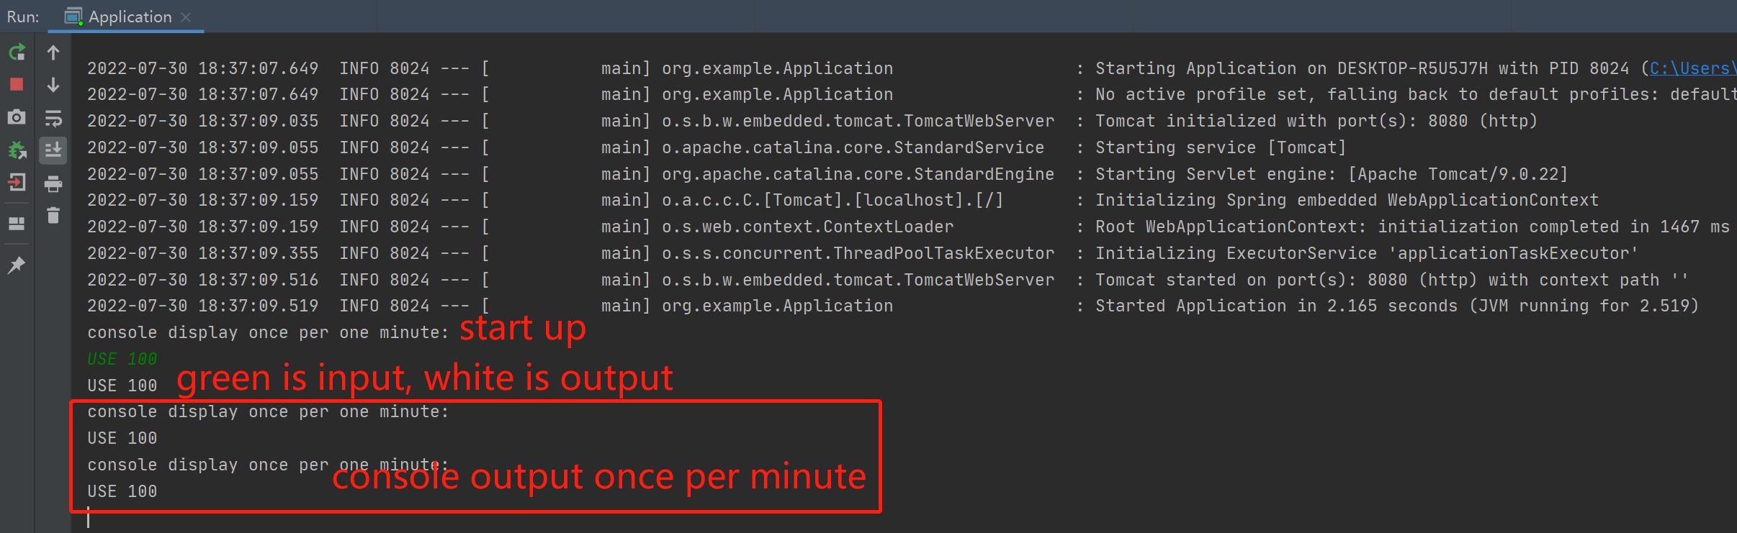

Upload file with Postman

Url : localhost:8080/input/uploadFile

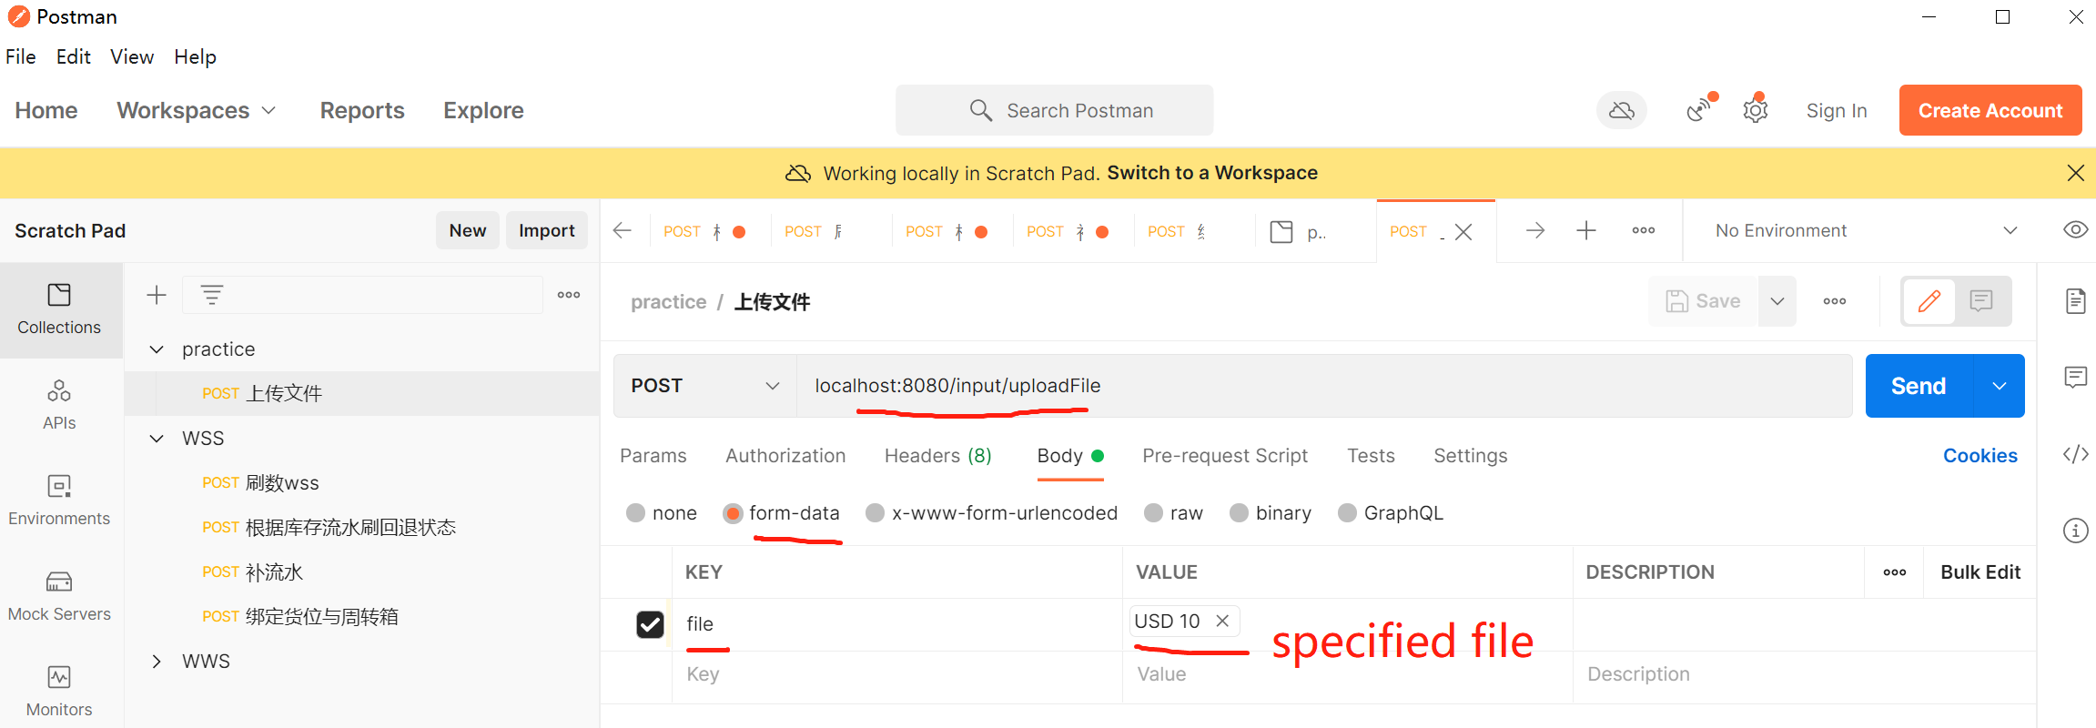

1. how to test

You can use filePath to set position and filename of new file

testCount is need to generate count of use case

validRate is valid case rate of testCount

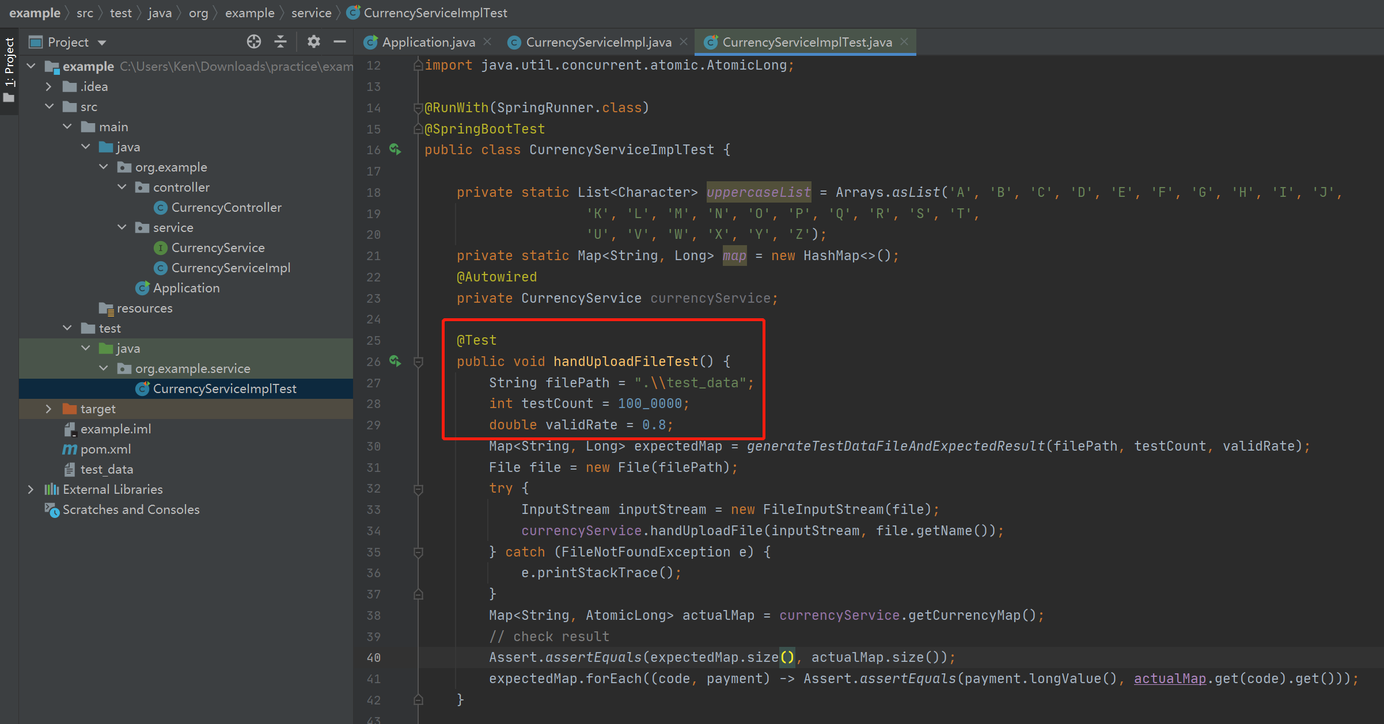

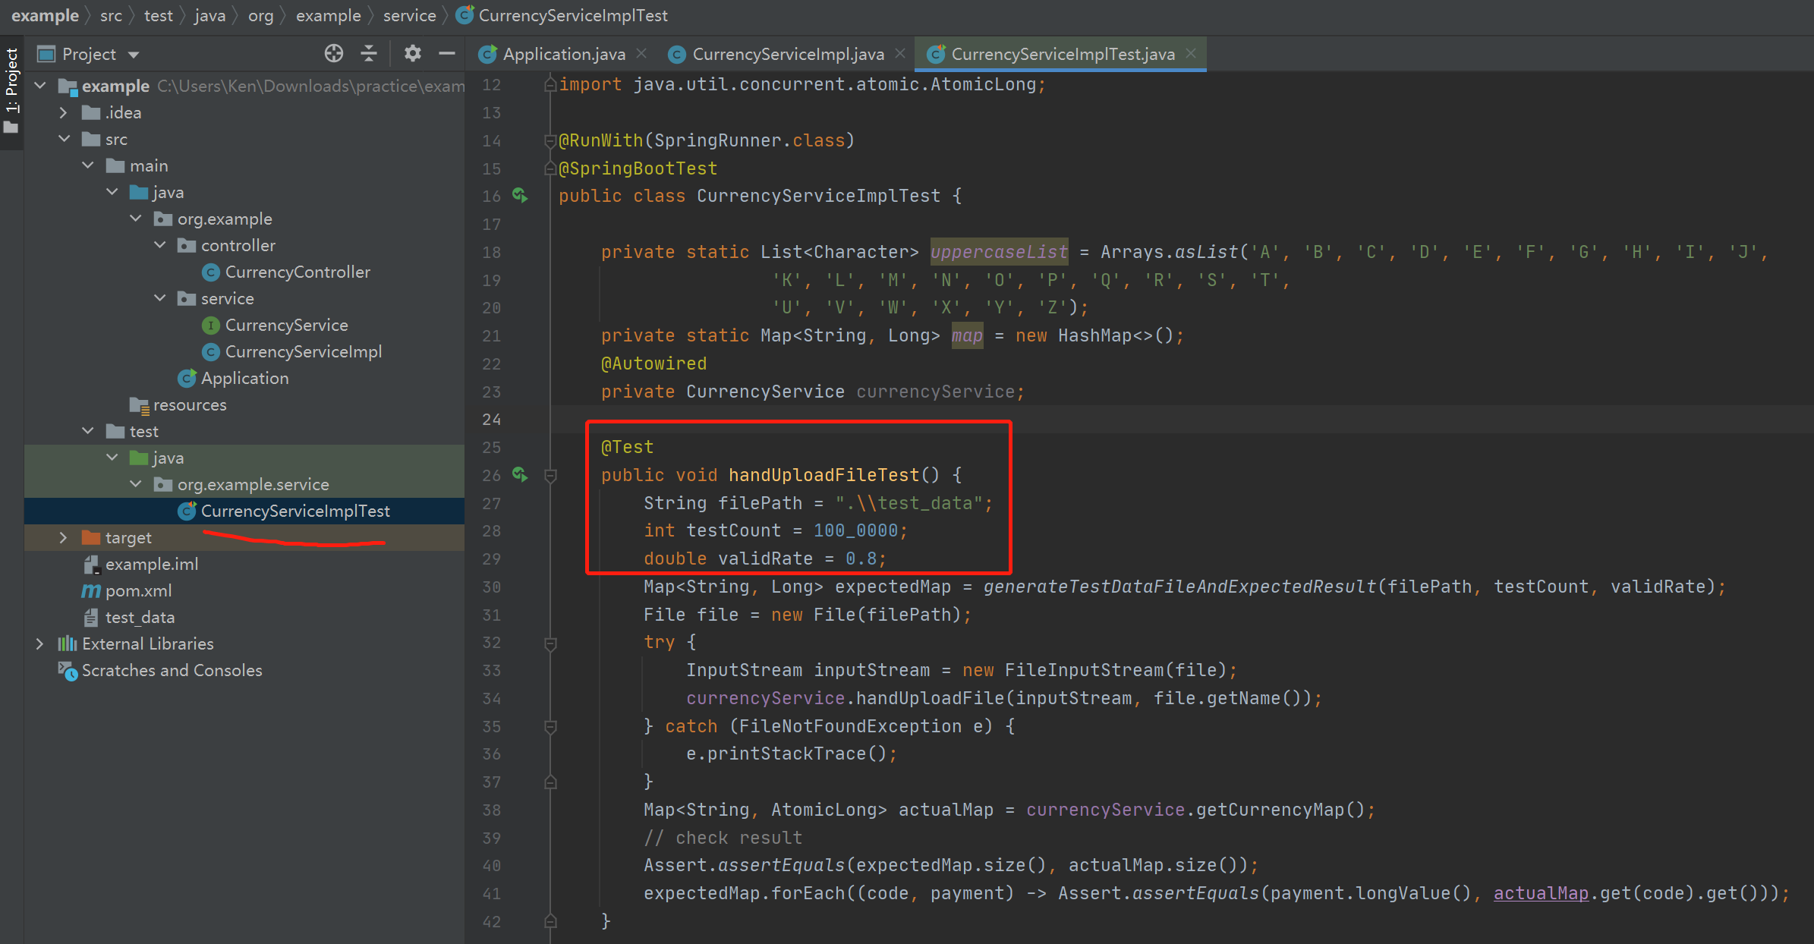

1. valid case instruction

valid case contains two partitions, split by one blank space,

one only is any uppercase 3 letter code,

another is only integer number

example:

USD 10

USD 10

USD 10